3rd INTERNATIONAL YOUTH SCIENTIFIC CONFERENCE ON LEISURE & RECREATION
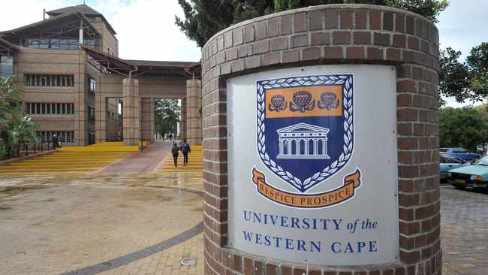

Organized by World Leisure Youth Ambassadors Committee of WLO and the University of the Western Cape (Department of Sports, Recreation & Exercise Sciences)

Introduction
The IYCLR will be a hybrid event inviting people to the University of the Western Cape, participating in person or joining the online platforms. All participants will get a certificate of attendance and the best presentations will get a recommendation to publish the results in World Leisure Journal. Participants will also get an opportunity to contribute to the upliftment in the South African communities. This event will have a multi-approach in that, participants will get an opportunity to experience South African environment, specifically disadvantaged communities (similar to the field school approach of the WLO). The event will also include a short field study tour visiting local projects in surrounding communities related to leisure for the disabled, sport and tourism. Additionally, time will be allocated for finalising the Young Peoples’ Book on Leisure and Safety.

Date: 29 March – 04 April, 2023

Goals of the conference
- Giving a platform for young people around the world to introduce their research results and thoughts on leisure and recreation
- Giving opportunities to meet young people and discuss leisure issues
- To have a chance to contribute to the upliftment of NGO’s and communities in the around the Western Cape in South Africa.
- To offer an opportunity to initiate leisure and recreation programmes within the Western Cape region.
- To offer an opportunity to unite and network young people around the world (create networking, collaboration and advancement of the leisure and recreation profession).

Participants: BSc/BA, MSc/MA, PhD students not older than 35 years old

Language of the conference: English

Theme: Promoting Leisure, Recreation, Physical activity [Exercise] & Tourism in Rural communities

Chairs of the conference
- Marie Young, PhD, chair WLYA Committee, University of the Western Cape, South Africa
- Miklos Banhidi, PhD, co-chair WLYA Committee, Szechenyi University, Győr, University of Pécs, Hungary

Stakeholders partnership
World Leisure Organization
University of the Western Cape

Scientific Committee
Prof Marie Young
Prof Miklos Banhidi
Dr Makhaya Malema
World Leisure Journal (Through Editor in Chief)

Youth organizers
- Makhaya Malema, Chante Johannes, Engel Mahlalela, Mignon Schiltz, Teniel Venter

Program

28-29 March 2023: Arrival and registration

30 March 2023 Morning Session
- Opening ceremony (will be broadcasted online too)
- opening speech by leaders of the university & WLO
- Cristina Ortega COO of the WLO

Afternoon session
- Committee meeting and planning
- Community visit and outreach programme
- Group meeting and session planning
- Drama, live performances, etc

31 March 2023
Morning session
- Opening
- Planning session
- Supervisors meeting and group allocation
- Community field project (in groups)

Afternoon session
- Report back and briefing
- Planning session for the YBOL Leisure & Safety Book
- Live performances

01 April 2023
Morning session
- Visit to the University of the Western Cape (Main campus & CHS building)
- Visit the stakeholders’ visit (e.g. City of Cape town, neighbouring Universities)

Afternoon session
- Continue working on the YBOL and community project
- Students presentation
- Debriefing

02 April 2023
Morning session
- Presentation of the community project and feedback
- Go present the project and give feedback to the communities/institutions

Afternoon session
- Final writing and consolidation of the YBOL
- Report back and reflection

03 April 2023
IYCLR Conference
- Young people’s Ambassador meeting
- Guest speaker address
- Student presentations (per theme track)
- Awards giving & Dinner with entertainment
04 April 2023
Departure

Registration

Participants are responsible to pay a participation of $150
Institutions are encouraged to supplement the participation fee with $170

All interested participants should fill a registration form and send it to the host organizations:
mmalema@uwc.ac.za; myoung@uwc.ac.za; and cc: wl.youthambassadors@gmail.com; miklosbanhidi@gmail.com

IYCLR’23 REGISTRATION FORM

FIRST NAME |  | SURNAME
CONTACT EMAIL |  | PHONE
COO-PRESENTER(S) NAME
COUNTRY OF RESIDENCE
NAME OF INSTITUTION, ORGANIZATION
TYPE OF PARTICIPATION | Personal attendance ☐ Online ☐  Book writing and camp ☐ Community volunteering ☐
TITLE OF THE PRESENTATION
ABSTRACT (max. 400 words)
Registration form should be sent to: mmalema@uwc.ac.za and myoung@uwc.ac.za
Due date later than 10th March 2023

