To Young People around the World

From Dr Makhaya Malema, Prof Marie Young, & Prof Miklos Banhidi
University of the Western Cape
World Leisure Youth Ambassadors

Subject: Invitation to be part of the 3rd International World Leisure Youth Scientific Conference and Field Study Tour: 29 March – 4 April 2023

This letter serves as an invitation to you to become part of the upcoming 3rd IWLYSC 2023. The University of the Western Cape will host the Conference in Cape Town, South Africa, endorsed by the World Leisure Organisation as part of the WL Youth Ambassadors’ programme.

The theme of the IWLYSC 2023: Promoting Leisure, Recreation, Physical Activity & Tourism in Rural communities.

Participants in this conference are young people (Undergraduate & Postgraduate students, aged 18-35) in the field of Leisure, Recreation, Physical Activity and Tourism. The Conference will be offered in a hybrid manner to accommodate participants who cannot attend in person.

The conference will also include a short field study tour visiting local projects in surrounding communities related to leisure for the disabled, sport and tourism. Additionally, time will be allocated for finalising the Young Peoples’ Book on Leisure and Safety.

Granting the significant opportunity this project provides to young people, your institution’s support would be greatly appreciated by sending 3 students accompanied by 1 staff member. Kindly note that the total cost per participant is $320 (breakdown as follows) for the duration of 8 days (arrival 28 March and departure 5 April). We propose that students pay $150 of the participation fee and their institution could contribute the remaining $170 per student.

The cost will cover ground transport, accommodation, all meals, a T-shirt and a hoodie (for the colder days) that participants need to wear when engaging with the community projects. Students are liable to pay for their own flights to Cape Town.

We know that it is not always in the student’s capacity to fund themselves for the total amount. We would appreciate your kind contribution towards the students from your Institution/ WLCE to cover some of their costs.

Kindly confirm your interest and participation in this conference before the due date: 10 March 2023.

Regards

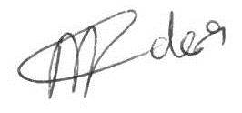
Dr. Makhaya Malema
mmalema@uwc.ac.za
World Leisure Youth Ambassador Country coordinator
University of the Western Cape

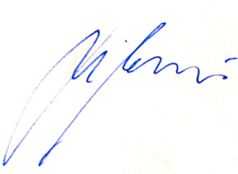

Prof Marie Young Prof Miklos Banhidi
myoung@uwc.ac.za miklosbanhidi@gmail.com
World Leisure Board member wl.youthambassadors@gmail.com
& Youth Ambassador Supervisor World Leisure Board member
University of the Western Cape Youth Ambassador Programme coordinator

