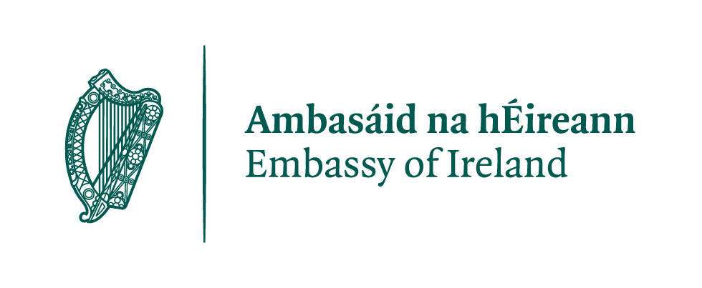
Embassy of Ireland - Hungary
Bursary Programme Statute

Purpose of the Programme

The Irish Embassy Bursary Programme was established by the Embassy of Ireland, the Irish Hungarian Business Circle (IHBC), and by the Forum of Scholars of Irish Studies in Budapest in November 2014. The Bursary Programme is based on the financial contribution of Irish companies and other organisations in Hungary, with the purpose of supporting Irish-related academic activities of a small number of Hungarian undergraduate, graduate and/or postgraduate students each year. The following fields of study are eligible for the Programme: Irish history, society, language, literature, culture, politics, music or visual arts. The Bursary Programme pays or contributes annually towards the costs associated with attending an Irish Summer School or conducting research in an Irish institute in any of the aforementioned fields.
The award is granted in accordance with this Statute and with any rules and laws governing grant and scholarship regulations in Hungary and in Ireland. The granting of the Bursary is subject to the sum of contributions and sponsorship for the Bursary Programme that is provided annually, as is the financial sum of the Bursary and number of Bursaries granted. The Embassy of Ireland in Hungary shall invite sponsors to contribute to the award annually.

The award is to be granted annually on the basis of academic criteria, specified in the Statute below. Members of the Forum for Irish Studies and the IHBC shall make the availability of the Bursary known each year in all Hungarian universities, colleges, institutions, and societies, where Irish related studies and/or research are conducted.
The procedure of the selection of the grantees is established in the Statute below and a panel, drawn from members of the Forum or such other persons as may be agreed within the Forum, shall be responsible for the selection.

Statute

Eligibility for the grant

Undergraduate, post-graduate and post-doctoral students registered at a Hungarian institution are eligible to apply, with the intention to:
- Attend a summer school in Ireland relating to the topic of the candidates research

- Visit to an Irish Research Institute (e.g.: National Library of Ireland, TCD Library, NUI Galway, Irish Film Institute or other relevant institutions) to carry out research directly related to their research topic

- Undertake an internship at an Irish business

Criteria for application
In order to apply, applicants must have completed or be in the final year of their degree at a Hungarian academic institution or be currently registered on an MA or PhD programme at a Hungarian academic institution. Applications from post-doctoral researchers registered with a Hungarian institution will also be accepted.
Applicants must provide evidence of a strong research interest in Ireland. This can be demonstrated through courses, projects, or research papers on an Irish related topic. If the applicant is pursuing MA or PhD study on an Irish topic, a confirmation from relevant supervisor is required.
If applying to a summer school, the applicant should provide evidence of pre-registration or a letter from organisers confirming preliminary registration. If seeking support to carry out research at an Irish research institute, a letter of invitation from the relevant institute should be attached to the application.

Application process
The applicant must submit a set of documents, by the relevant deadline to the Embassy of Ireland by email (budapestembassy@dfa.ie) or by post (Embassy of Ireland, 1054 Budapest, Szabadság ter 7-9, Bank Center, Granite Tower VI.)

A completed application should include:

- Completed Application Form
- CV
- Statement of purpose for attending summer school/research trip or project description, or research proposal signed by his/her supervisor from his/her host university or letter of invitation or registration form is required.

- For students aiming to attend a summer school, a letter of recommendation is required from an academic. For students submitting an application for research, a statement of endorsement from the project supervisor is required.

Evaluation of applications

- Selection Panel
A Selection Panel, drawn from members of the Forum, or such other persons as may be agreed within the Forum, shall be responsible for the selection. The Selection Panel shall consist of a minimum of three and a maximum of five members. The members of the Forum shall nominate members to the Selection Panel for a period of one year at its annual meeting in November.

- Selection Procedure
At the close of the application deadline, the Embassy will circulate all the applications to the members of the selection panel within five working days. The members of the selection panel shall have five working days to review all the applications.
Each member of the selection panel may indicate to the other members of the panel their first and second choice and submit a short report to the other members of the panel explaining how the chosen candidates meet the criteria above. Reports should be submitted by email. Each choice selection and report must be submitted before the agreed deadline.
The panel shall, if necessary, meet to review and confirm their final decision. The decision of the panel is final. Within five days, after the conclusion of work of the Selection Panel, the panel shall inform the Embassy and IHBC of their decision.

Bursary Contract

The Irish Embassy shall inform the successful candidate that they have been granted the award and invite them to sign a Bursary Contract with the IHBC. In the Bursary Contract, the contracting parties (IHBC and grantee) specify what costs the grant is used for, and what costs the grantee has to justify with relevant proof of payment or receipts.
Under the Bursary Contract, the grantee undertakes that with the acceptance of the award they shall conclude the research or attend the summer school that is specified in their work plan by the given deadline, and submit a brief report on completion.
Each bursary grantee shall arrange all travel practicalities with TENSI Travel Agency and the transfer of tuition fees and registration fees will be arranged with the IHBC. The grantee is obliged to abide by the terms of the Bursary Contract signed with the IHBC. In case the grantee fails to complete the programme, they are responsible for repaying the bursary amount.

Announcement of the Award

The awards will be announced and presented at the annual Alumni-Bursary Award Reception in April.

