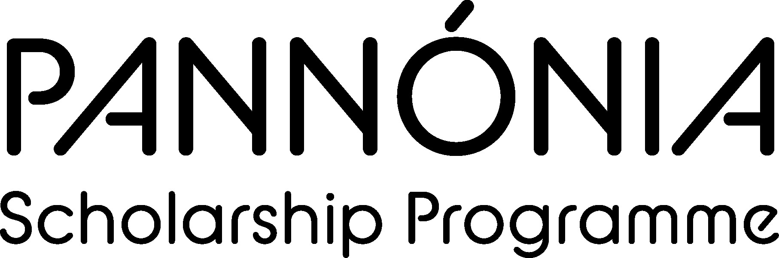
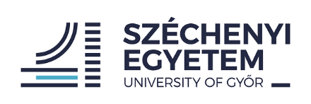

Letter of participation
2024/2025

It is hereby certified that the following student has participated in the Pannónia programme as following:

Name:
Birth date:
Home institution: | Szechenyi Istvan University (HU GYOR01)
Host institution
Study/Placement period Day/Month/Year: | From | To
Field of study/placement:

Date:_________________

___________________________ (signature and stamp)

Name of the signatory:________________________________________________

status:_____________________________________________________________

