
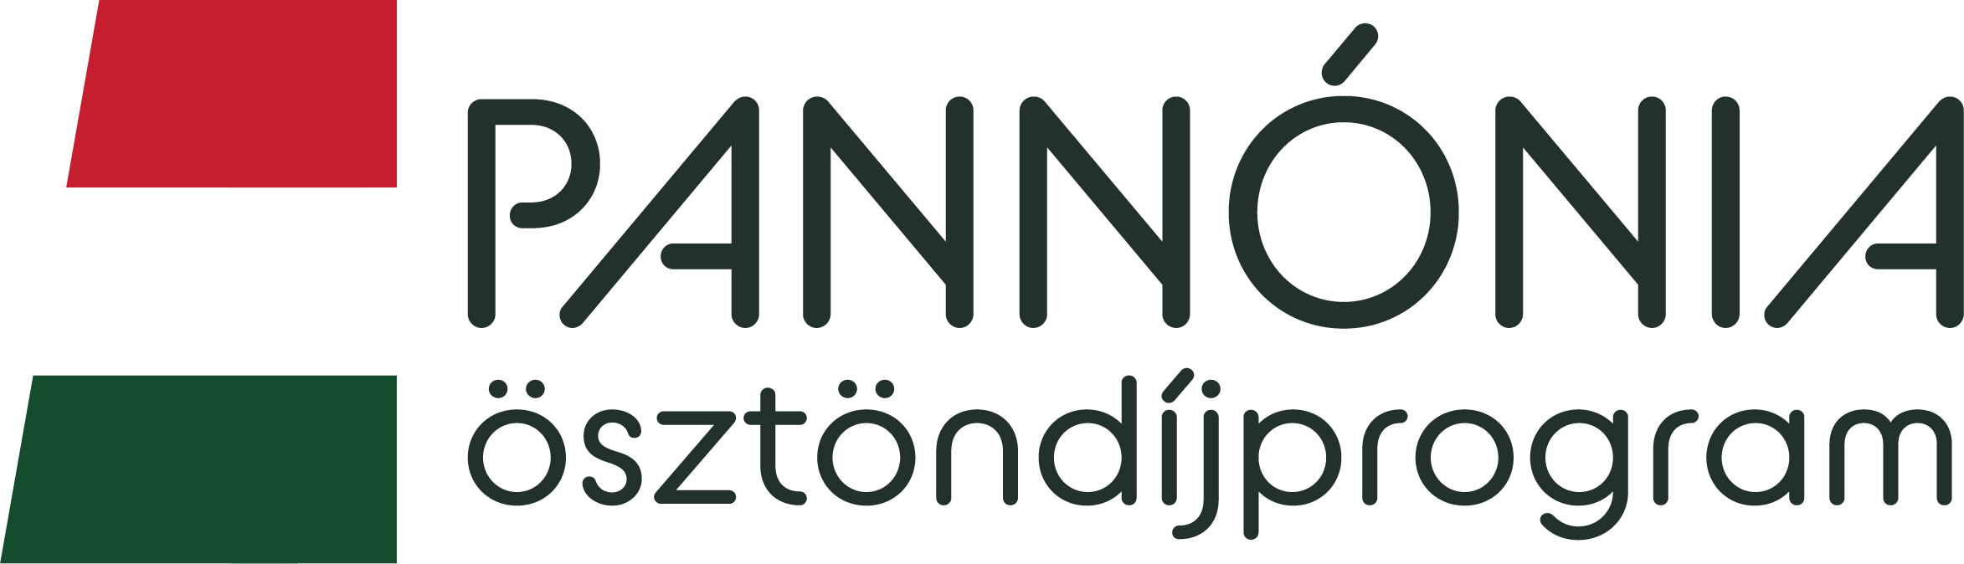

A U T H O R I Z A T I O N

We, hereby authorise that …………………..……………………...........(name), student enrolled in 20.../20... Academic Year, in the …………. semester, may begin an Academic Mobility in the framework of Pannónia Scholarship at ………………….……………………………………………(receiving institution) institution.
Győr, ……………………
………………………………………… ……………………………………
Programme Supervisor Departmental Coordinator
To be submitted: To the International Programmes and Alumni Centre (IG 103 office) before signing the scholarship agreement.

